DISCOVERING PARAMETER EFFECTS IN GYROSYNCHROTRON RADIATION

Kevin Tong
Union County Magnet High School
Under guidance of Gelu Nita and Gregory Fleishman
Center for Solar-Terrestrial Research, New Jersey Institute of Technology

ABSTRACT

Gyrosynchrotron (GS) emission, or electromagnetic radiation emitted by particles such as nonthermal electrons gyrating around magnetic field lines, makes up a large portion of the high-frequency emissions observed during solar flares. To model flares, we utilized GX Simulator (Nita et al. 2015), an IDL-based tool developed for investigating various solar emissions. Using fast GS codes (Fleishman and Kuznetsov 2010, 2014), the tool allows for the rapid simulation of the flare’s progression by computing the radiation that user-generated 3D magnetic field and plasma models emit across various spectrums. To aid the modeling, here we describe how the GS emission changes when various involved parameters change.

DISCOVERING PARAMETER EFFECTS

Here, we test the various parameters and explore how changing each parameter individually affects the intensity curve by using a testing routine called GS_trends_test.pro (http://bit.ly/2hXKV0Z).

Area
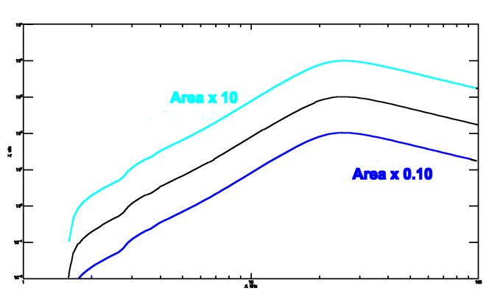
- Intensity increases by a factor of roughly 10 when area is increased by a factor of 10. The graph uniformly shifts up.
- Intensity decreases by a factor of 10 when the area is decreased by a factor of 10. The graph uniformly shifts down.
Due to the uniform composition of the viewing area, any change in area results in a corresponding/ proportional change in measured intensity.
Depth

- An increase in depth causes an increase in intensity for higher frequencies only.
- A decrease in depth causes a decrease in intensity for higher frequencies only.
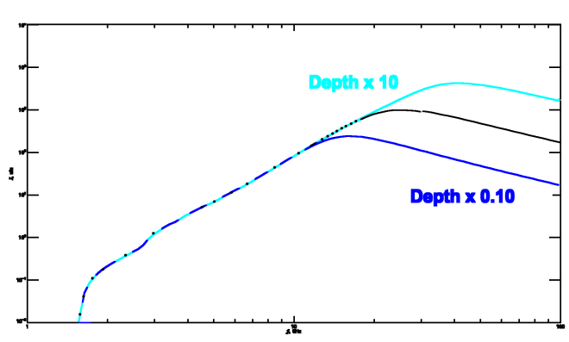Since plasma is more optically thin to higher frequencies, any change in viewing depth affects their intensities more than for lower frequencies. The optically thick nature of plasma with regards to lower frequencies means that a change in depth of plasma has an only negligible effect on the amount of radiation emitted, as the radiation emanating from deeper layers is absorbed regardless of the depth of measurement.
Temperature
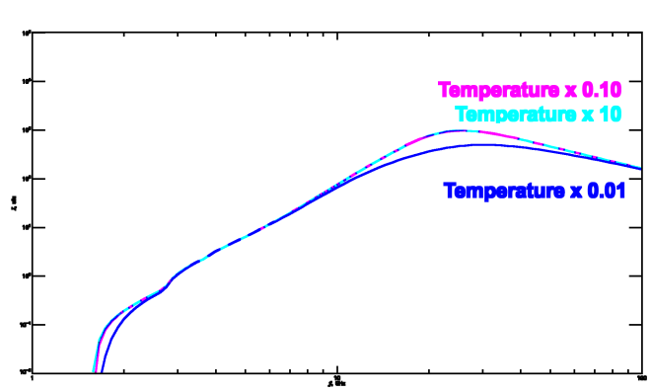
- An increase in temperature has negligible effect on intensity.
- A drastic decrease in temperature creates a decrease in peak intensity and very low frequency intensity.
Higher temperatures cause thermal plasma to become more optically thin. Therefore, an increase in temperature makes already optically thin plasma even thinner, creating negligible changes in intensity. However, a decrease in temperature makes the plasma more optically thick, lowering intensity in the low frequency, where there is more absorption of radiation.
In addition, when the temperature is lowered, the plasma around the peak becomes optically thick, meaning that, due to radiation absorption, the viewed intensity is the maximum possible intensity, with any additional emissions soaked up by plasma.
Minimum Electron Energy(E_min)
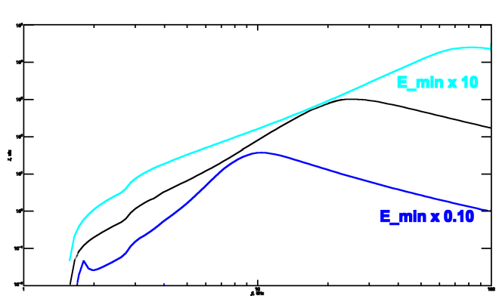

- An increase in minimum electron energy increases the intensity of low and high frequency radiation and shifts the graph to the right.
- A decrease in minimum electron energy causes a decrease in the low and high frequency radiation and shifts the graph to the left.
Since a higher E_min causes electrons to become more energetic and more energetics electrons tend to release higher frequency radiation, changes in E_min tend to shift the peak intensity in the direction of high or low frequency depending on electron energy when all other factors are kept constant. In particular, the corresponding nonthermal electron density (n_b) is kept constant while E_min is changed.
Maximum Electron Energy (E_max)
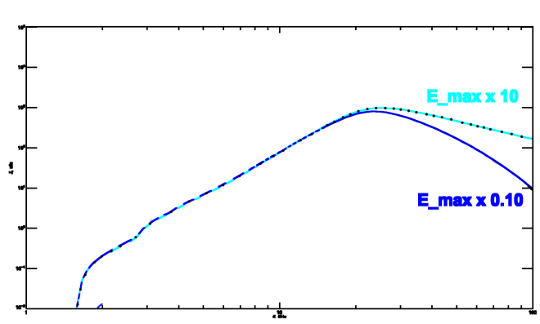
- An increase in maximum electron energy does not have any significant effect on the graph.
- A decrease in maximum electron energy decreases the intensity for high frequency radiation.
An increase in maximum electron energy creates a proportional increase in high frequency emissions, but at very high frequencies that increase is negligible. However, a decrease in maximum electron energy decreases the amount of high energy electrons available to emit high frequency radiation, which results in lower observed intensity at high frequencies.
When maximum energy is decreased, the high energy end of the electron power-law energy distribution ${(n}_{b}∝E^{-δ})$is also decreased, leading to a sharp decline in high frequency emissions and the lowering of intensity of those emissions.

Delta_1 (δ₁)
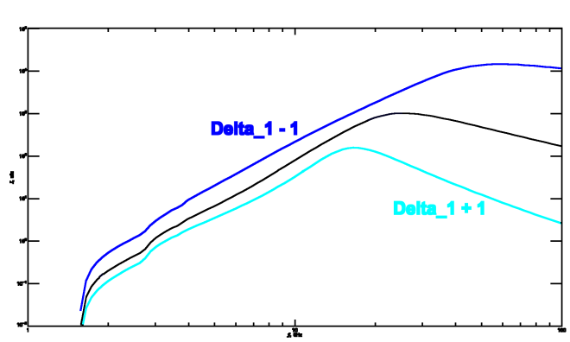
- An increase in Delta_1 causes an overall decrease in intensity, especially in high frequency regions.
- A decrease in Delta_1 causes an overall increase in intensity, especially in high frequency regions.
As Delta_1 is changed, the slope of the energy distribution graph (E^-Delta_1) shifts inversely proportional to the change in Delta_1, leading to an overall increase in emissions when Delta_1 is decreased and an overall decrease in emissions when Delta_1 is increased. These changes especially affect the higher frequencies, where gyrosynchrotron emissions form a much larger part of the overall intensity (as opposed to free-free emissions).
Thermal Electron/Plasma Density(n_therm)
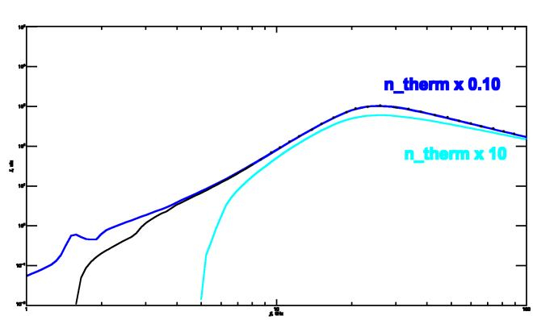
- An increase in thermal electron density, the intensity decreases, especially in low frequencies, where it completely eliminates intensity.
- A decrease in thermal electron density increases the intensity of low frequency radiation, with the intensity converging with normal intensities as frequency increases and optical thickness decreases.
As thermal electron (and plasma) density increases, the Razin Effect causes a drop-off in the intensity of low frequency emissions. At higher frequencies, due to the optical thinness of thermal plasma, changes in thermal plasma do not affect intensity. When thermal electron density decreases, the Razin Effect disappears for lower frequencies, resulting in a more gradual slope and an increase in intensity for very low frequency emissions.
Nonthermal Electron Density (n_b)
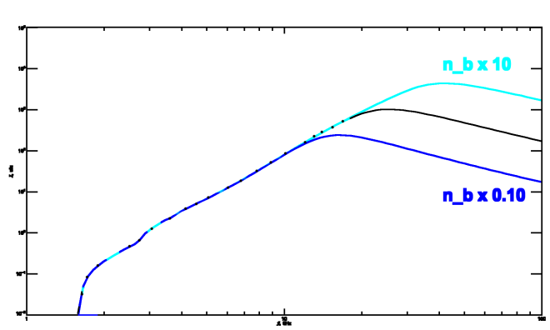
- An increase in nonthermal electron density causes an intensification of intensity for high frequency emissions.
- A decrease in nonthermal electron density causes a reduction in intensity for high frequency emissions.
An increase in nonthermal electron density increases the number of electrons available for emission. However, due to the optically thick nature of the low frequency emission, the increase in electron density only affects high frequency intensity, where the plasma is optically thin enough to allow the additional electrons’ emissions through. This is similar to how depth affects intensity.
Additionally, as nonthermal electron density increases, previously optically thin portions of the graph become optically thick due to the increased absorption from the greater number of electrons. The peak frequency, occurring at the point where the optical thickness changes, moves up along the curve as higher frequency emissions become optically thick. This change in optical thickness also leads to an increase in high frequency intensity while lower frequency intensity remains constant.

Magnetic Field (B)
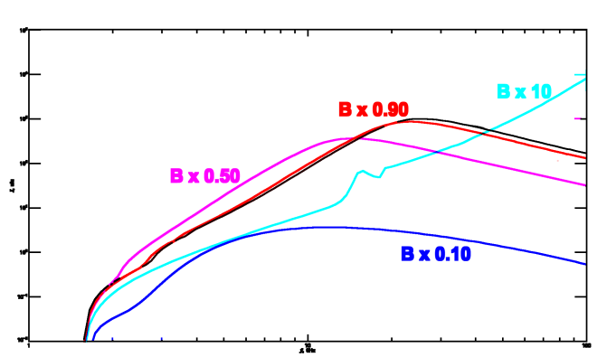
- Increasing the magnetic field causes the intensity graph to shift generally to the right, with lower intensities for low frequencies and higher intensities for high frequencies.
- Decreasing the magnetic field causes the intensity graph to shift generally to the left, with higher intensities for low frequencies and lower intensities for high frequencies.
Making the magnetic field stronger increases the efficiency of nonthermal electron emissions and makes the electrons girate at a higher frequency, leading to higher frequency emissions. The increased efficiency also applies to gyrosyncrotron absorption, which is why the higher magnetic fields reduce the intensity of lower-frequency emissions. Due to those areas being optically thick, the increase in efficiency does not lead to more emissions escaping. However, the increased absorption can decrease the amount of escaping emissions.

Angle between Viewing Line and Magnetic Field Line (theta)
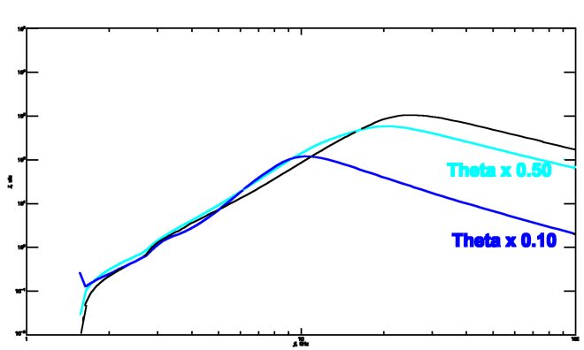
- Decreasing theta causes a slight increase in lower frequency intensity, followed by a drastic decrease in high frequency intensity.
Magnetic force (B) is proportional to the sine of theta, the viewing angle. Since magnetic acceleration and therefore emission frequency is in turn proportional to B, the lower the viewing angle, the lower the general trend of emissions.

REFERENCES

Fleishman, G. D., Kuznetsov, A. A. ApJ 2014. V. 781. Id. 77; ApJ 2010. V. 721. P. 1127.

Nita, G. M., Fleishman, G. D., Kuznetsov, A. A., Kontar, E. P., and Gary, D. E. ApJ 2015, 799, Id: 236.

Gregory D. Fleishman, Yan Xu, Gelu N. Nita, and Dale E. Gary, A. A. ApJ 2016, 816:62.

