Russian Academy of Sciences (RAS)
Russian Foundation for Basic Research
Department of Earth Sciences, RAS
Department of Physics, RAS
A.F. Ioffe Physical-Technical Institute, RAS
O.Yu. Schmidt Institute of Physics of the Earth, RAS
International Union of Geodesy and Geophysics (IUGG)

VIII International Workshop
“Physics and Forecasting of Rock Destruction”
May 24-28, 2010
St. Petersburg, Russia
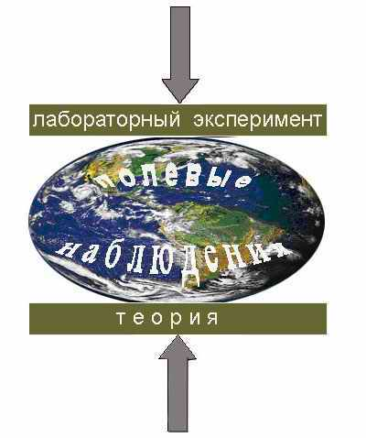

2nd ANNOUNCEMENT

Dear Colleague,
By this, Organizing Committee is pleased to inform you that your contribution has been accepted for oral presentation and invites you to participate in the VIII International Workshop.

Chairman of the Organizing Committee,
Dr. Sci., Professor

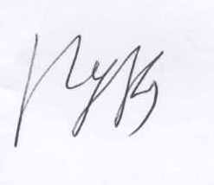
/Viktor S. Kuksenko/
Important New Information

Please note that Workshop’s Dates and Place have been changed!
PLACE: VIII International Workshop will be held in St. Petersburg, at Ioffe Physical-Technical Institute of the Russian Academy of Sciences (PTI).
DATE: May 24 – 29, 2010; Working Days: May 25, 26, 27 and 28
Conference Fee – 1,000 Rubles (to be paid at Registration)
Presentations:
Oral - MS PowerPoint;
Poster - A3
Publication: Volume of Collected Abstracts will be published and given to registered participants.
Hotel Information: Organizing Committee has booked rooms in the Hotel “ORBITA” (http://spborbita.ru/), situated near PTI, about 15-20 min walk.
Single room – 1700 Rubles (Breakfast included).

After April, 20th Web site of the Workshop will be opened (http://www.ioffe.ru/kuksenko2010/).

Please, confirm your participation by e-mail before April 24th, 2010 and include in the message the following data:
Passport Series No issued by issuing Date valid till
Permanent address: Country, City, street, No
Institution: Name, Address

Workshop’s Program will be sent to all registered participants by May 16th, 2010

Contact Persons:
Secretary: Dr. Maria Korsukova, maria.korsukova@mail.ioffe.ru

Scientific Secretaries: Dr. Ekaterina Damaskinskaya, kat.dama@mail.ioffe.ru
Tel.: +7(812) 292 73 22; Fax: +7(812) 297 14 45
Dr. Alex Zavyalov, zavyalov@ifz.ru
Tel./ Fax: +7 (495) 254-2478

