Title of the Spin Waves 2011 abstract in 14pt bold
F. Author¹, S. Author² and Th. Author² 12pt
¹Institution, Postal code, City, Country, ²Institution, Postal code, City, Country, italic 11pt

This page is an example of presentation of your abstract (invited, contributed oral or poster). Since the abstracts will be directly reproduced in a volume to be distributed to the participants, please follow carefully the instructions. Only Word document (Abstracts_SW2011_Name.doc) is acceptable. The text must fit (preferably filled up completely) into a frame 16 cm wide and 24 cm high. Top margin 2.5 cm, left margin 2.5 cm. The complete abstract must fit into one page. Please provide also the second page with the abstract title, presentation and section preferences as well as the name, title, complete address, phone, fax numbers, and e-mail address of the corresponding author.
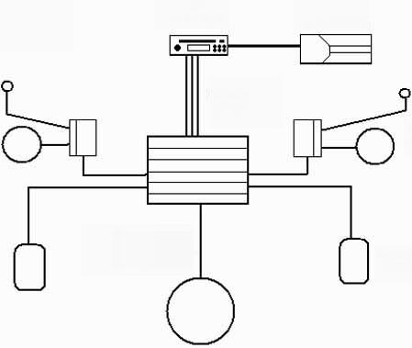
Fig. 1 Experimental setup, 11 pt | Fig. 2 Results of our measurements, 11 pt
Body text is single-spaced typed in Times New Roman 12pt, justified. The title is 14pt bold. The presenting author should be underlined. Leave one line after the authors’ names and affiliation. Do not separate paragraphs by inserting blank lines. Do not indent paragraphs. The figures, if necessary, should be inserted into the text. Please note, that the printed version of the Symposium Abstracts will be black and white. References, typed in Times New Roman 11pt, should appear at the end of the text [1]. Abstracts that do not comply with these requirements are not eligible for publication in the Symposium Abstracts.

[1] S. M. Body and S. Else, Phys. Rev. Lett. 90, 1003 (1898).
[2] S. V. Vonsovskii, Magnetism (Nauka, Moscow, 1971).
[3] F. Author, Phys. Rev. B 152, 77 (1998).
Title of the Spin Waves 2011 abstract in 14 pt bold

Presentation preference:
(I if invited, O for oral, P for poster)

Section preference:
(Choose from 1 to 7 or type in you suggested subject)

- Ultrafast magnetic dynamics
- Quantum and frustrated magnets
- Magnonics, magneto-photonics, magneto-optics
- Multiferroic, electromagnons
- Spintronics, nanostructures, magnetic films
- X-ray and neutron probe of magnetism
- Nonlinear phenomena and relaxation processes

Corresponding author:
Name, title
Affiliation/institution
Address
Postal code, City
Country
Phone
Fax
e-mail

