Title of the Spin Waves 2015 abstract in 14pt bold
F. Author,¹ S. Author,^{2*} and Th. Author² 12pt
¹Institution, Postal code, City, Country, 11pt italic
²Institution, Postal code, City, Country, 11pt italic
* e-mail address of the presenting author, 11pt italic

This page is an example of presentation of your abstract (invited, contributed oral or poster). Since the abstracts will be directly reproduced in a volume to be distributed among the participants, please follow carefully the instructions below.
The maximum abstract size is limited to one page. The text should fill completely one page. The abstracts should be submitted to the e-mail address optics-lab@mail.ioffe.ru with the subject Abstracts_SW2015_YourName. Abstracts submission deadline is March 1, 2015. Only Word document (Abstracts_SW2015_YourName.doc) is acceptable. Top margin is 2.5 cm, left margin is 2.5 cm. The text field dimensions are 16 cm wide and 24 cm high.
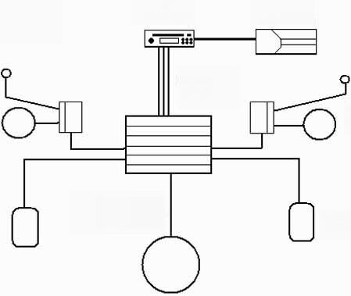
Fig. 1 Experimental setup, 11 pt | Fig. 2 Results of our measurements, 11 pt

The title is in Times New Roman 14 pt, bold, centred.
The author’s names are in Times New Roman 12 pt, centred. The name of the presenting author should be underlined. The author’s affiliations are in times New Roman 11 pt, italic, centred. On the next line you can provide the contact e-mail address of the corresponding or presenting author (11 pt, italic, centred). Please leave one line after the authors’ affiliations.
Body text is single-spaced, typed in Times New Roman 12 pt, justified. Please do not separate paragraphs by inserting blank lines. Do not indent paragraphs.
The figures, if necessary, should be inserted in the text. Please note, that the printed version of the Symposium Abstracts will be black and white. References typed in Times New Roman 11pt should appear at the end of the text following one blank line [1].
Please, note that abstracts that do not comply with these requirements are not eligible for publication in the Symposium Abstracts Booklet.
Please provide also the second page (see the next page) containing the abstract title, presentation and section preferences as well as the name, title, and contact details of the presenting author.

[1] S. M. Body and S. Else, Phys. Rev. Lett. 90, 1003 (1998).
[2] S. V. Vonsovskii, Magnetism (Nauka, Moscow, 1971).
[3] F. Author, S. Author, Th. Author, et al., Phys. Rev. B 152, 77 (1998).
Title of the Spin Waves 2015 abstract in 14 pt bold

Presentation preference:
O for contributed talk (15 min)
P for poster presentation (A0, portrait)

Section preference:
(Choose from 1 to 10 or type in your suggested subject)

- Ultrafast magnetization dynamics
- Excitations in quantum and frustrated magnets
- Spin waves on surfaces and in multilayers
- Spintronics and magnetism at the nanoscale
- Magnonics, magneto-photonics, magneto-plasmonics
- Spin-related phenomena in multiferroics
- Nonlinear spin-wave phenomena and relaxation processes
- Novel probes of magnetism: THz, X-rays, neutrons, etc.
- Spin-torque effects: oscillators, switching, DW motion
- Advances in spin-based devices and technology
Your suggestion:_____________________________________

Presenting author:
Name:
Title:
Affiliation:
Contact phone number:
Contact e-mail address:

